HANDS-ON 9:State Management — NgRx Store, Actions, Reducers, Effects & Selectors
Project Structure:
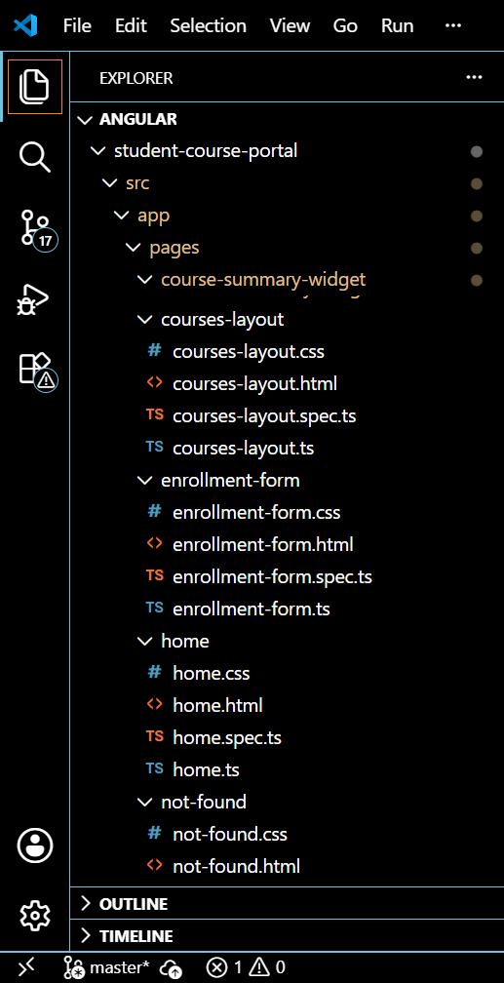
Enrollment-action.ts
Enrollment.actions.tsimport { createAction, props } from '@ngrx/store';

export const enrollInCourse = createAction(
'[Enrollment] Enroll In Course',
props<{ courseId: number }>()
);

export const unenrollFromCourse = createAction(
'[Enrollment] Unenroll From Course',
props<{ courseId: number }>()
);

export const setEnrolledCourses = createAction(
'[Enrollment] Set Enrolled Courses',
props<{ courseIds: number[] }>()
);

Enrolment.reducer.ts
import { createReducer, on } from '@ngrx/store';
import { enrollInCourse, unenrollFromCourse, setEnrolledCourses } from './enrollment.actions';

export interface EnrollmentState {
enrolledCourseIds: number[];
}

export const initialState: EnrollmentState = {
enrolledCourseIds: []
};

export const enrollmentReducer = createReducer(
initialState,
on(enrollInCourse, (state, { courseId }) => ({
...state,
enrolledCourseIds: [...state.enrolledCourseIds, courseId]
})),
on(unenrollFromCourse, (state, { courseId }) => ({
...state,
enrolledCourseIds: state.enrolledCourseIds.filter(id => id !== courseId)
})),
on(setEnrolledCourses, (state, { courseIds }) => ({
...state,
enrolledCourseIds: courseIds
}))
);
Enrollment.selectors.ts
import { createFeatureSelector, createSelector } from '@ngrx/store';
import { EnrollmentState } from './enrollment.reducer';
import { selectAllCourses } from '../course/course.selectors';

export const selectEnrollmentState = createFeatureSelector<EnrollmentState>('enrollment');

export const selectEnrolledIds = createSelector(
selectEnrollmentState,
(state) => state.enrolledCourseIds
);

export const selectEnrolledCourses = createSelector(
selectAllCourses,
selectEnrolledIds,
(courses, enrolledIds) => courses.filter(c => enrolledIds.includes(c.id))
);
OUTPUT:
